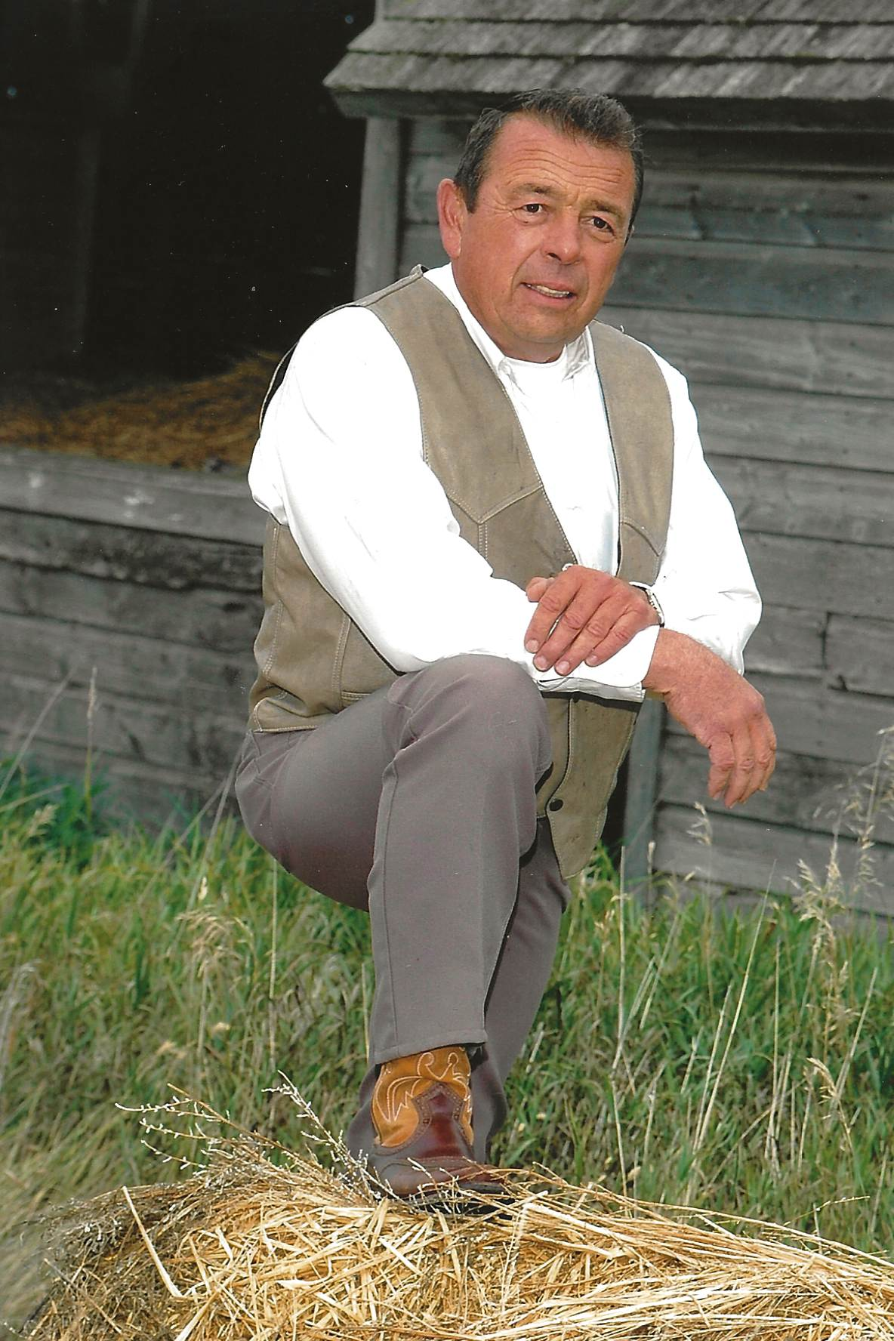David Peter Prosofsky (Chatter)

1950 - 2024

With heavy hearts we announce the loving husband of Susan Prosofsky passed away Sunday, September 15th at the age of 74.

David was born August 22nd, 1950 to Peter and Eleanore Prosofsky of Kenaston, SK. David grew up on the family farm east of Kenaston. David loved sports, especially baseball and fastball. He loved being outdoors, hunting, fishing, snowmobiling, and camping, especially at his brothers resort at Big River.

David married Susan (Sarich) in 1970 and had three children: Mike, Carla, and Wyatt. David started pipelining at a young age. His reputation was built on his work ethic, loyalty, and exceptional leadership skills. His name is known throughout the industry. David also loved farming, both grain and cattle, and working in his yard. Together he and Susan built beautiful yards that they took great pride in, naming them Eagle View Farms. He was always there to help a neighbour, family, and friends. David loved watching his grandchildren participate in various sports and activities.

David was predeceased by his parents Peter and Eleanore; mother and father in-law Mike and Lily; sisters Faye, and Lucille Wunsch; brothers Christopher, Anthony (Joey), Peter, Robert, Nic; nephew Shad Wunsch; brother in law Stan Zdunich; and sisters in-law Jewel Prosofsky, Susan Prosofsky, and Marianne Prosofsky.

He is survived by his loving wife Susan; children Mike (Alison) and their children Madison (Brett), and Marshall; Carla (Kelly) and their daughter Kabree; Wyatt (Isabella) and his children Jessica, Milayna, Oakley, and Levi. Siblings Carol (Willard), Linda (Ward), Ivan (Leigh Anne), Alfred (Pat); sisters in-law Carol Prosofsky and Deb Prosofsky; brother in-law Don Wunsch, as well as numerous nieces, nephews, and his pipeline family.

Susan and the family would like to thank David’s many caregivers and all those who stopped to visit.

The family invites those able to join them for a celebration of David’s life to be held Tuesday, September 24th at 1:00p.m. at the Hanley Centennial Hall. David valued his community and did whatever he could to help it flourish. For those so wishing, a donation in David’s memory can be made to Hanley Minor Hockey, Hanley Minor Ball, or the Hanley Fire Hall.

Hanson’s funeral home of Davidson in care of arrangements.